The DDDv2 model

Thomas Skaugen, HM/NVE

1. **Introduction**

The DDD (Distance Distribution Dynamics) model is a catchment scale rainfall- runoff model (Skaugen and Onof, 2014; Skaugen et al, 2020).

The DDDv2 version of the model combines the DDD model for natural catchments (Skaugen and Onof, 2014) and DDDUrban for urban catchments (Skaugen et al, 2020) . The DDDv2 model hence models hydrology for landtypes such as soils (i.e. permeable areas), impermeable areas (i.e. roofs and roads), wetlands, glaciers and river networks. Features of the new model:

### 1.1 The model simulates the hydrological dynamics (routing) of:

-Permeable areas (P)

-Impermeable areas (IP)

-Wetlands (only one type- Bogs. Fens we be incorporated at a later stage)

-Glaciers (static glacier extension)

-RiverNetwork

-Lakes

### 1.2 Additional features

- Energybalance modelling of snowmelt

- Energybalance modelling of evapotranspiration (Priestly-Taylor)

- Infiltration capacity for P and IP areas

- Dynamic snow distribution

- Surface moisture accounting is carried out for 10 elevation zones

- Subsurface moisture accounting is carried out for the catchment using a 2D (hillslope) representation of subsurface soil moisture.

- The model can store model states and start from model states

The flow dynamics for the features in 1.1 are carried out using distance distributions and celerity (velocity) estimates in the construction of unit hydrographs. The unit functions**/transfer functions**/unit hydrographs are used to distribute the impulse in time to the recipient. Impulses are typically rainfall/snowmelt/glacier melt on the hillslope, whereas the recipient can be river network and lake. The job of the transfer function is to describe the temporal distribution of the hillslope runoff to the river network. Another transfer function will describe the temporal distribution of the flow in the river network to the lake.

The catchment in DDDv2 is divided according to which landscape types (Lst) have storage capacity. In the DDDv2 model these are permeable areas (P), impermeable areas (IP) and Wetlands (Bogs). In the previous DDD model the Lst soils (P-area) and Wetlands have storage capacities. The Lst’s river network and lakes in DDDv2 are just represented by their transfer functions (se paragraph above), whereas the glacier just provides an impulse and has no reservoir or transfer function (the distance distribution for glaciers is that of the soils. The catchments total river network has been expanded due to the presence of glaciers. In total, the water dynamics of the model can be seen as represented by three separate DDD models; for P, IP and wetlands.

Note that calculations relate to glaciers only apply to P-areas, and the area of glaciers (and the distance distributions) is included in the P-area

The moisture input (rainfall/snowmelt/glacier melt) is generated per elevation zone and is the unput to be accounted for indiscriminately by P, IP and Bog.

Figure 1, The structure of DDDv2. See parameterfile in section 3 for explanation of parameters.

## Set-up, prerequisites and running the model

The DDDv2 model is coded in Julia (download Julia from <https://julialang.org/>) and can be edited in Jypyter notebooks (hereafter called «notebook»), in Notepad ++, or in Visual Studio Code.

Download Julia and Jypyter, and open Julia and write in the Julia window: “import Pkg; Pkg.add("IJulia") “

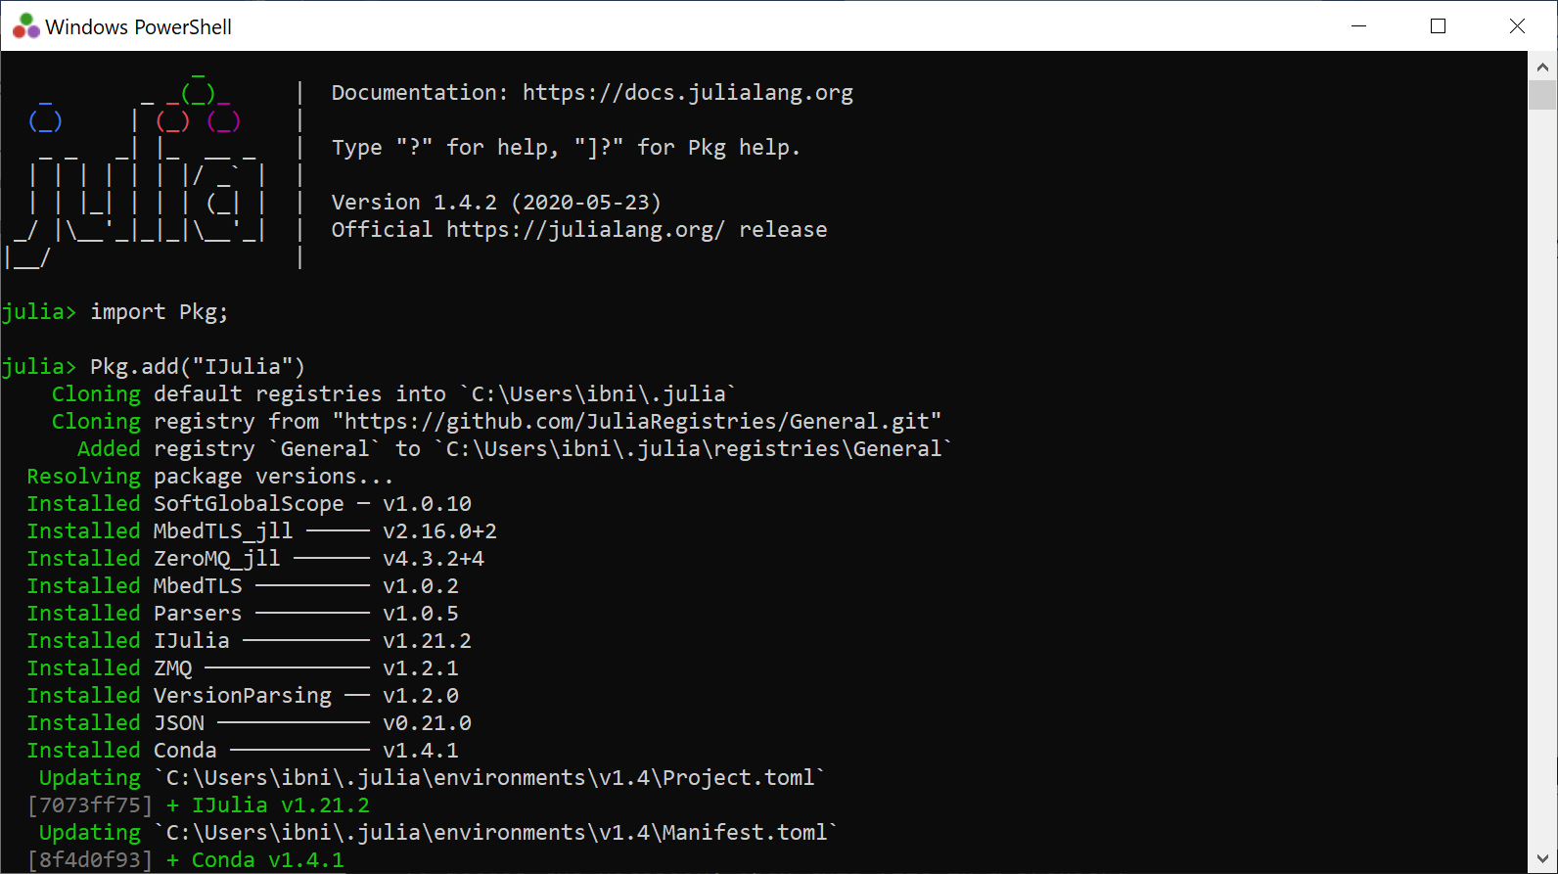

This ensures that Julia and Jypyter (in mysterious ways) are connected.

After, download the following packages (while still in the Julia window) needed by DDD. Write:

Pkg.add("CSV")

Pkg.add("Distributions")  
Pkg.add("LsqFit")  
Pkg.add("Statistics")  
Pkg.add("Dates")  
Pkg.add("DataFrames")

Pkg.add("BlackBoxOptim")  
Pkg.add("Plots")

Pkg.add("JLD2”)

The package «IJulia» must be installed before you can open a notebook.

We run the model using the run script, “RunDDDv2”. I gave put the «Run script» on my One-drive (from experience it seems to be easily accessible from Jyputer).

Now open RunDDDv2.ipynb in notebook and edit all the paths so that they can be found by the program dem. The top of RunDDDv2 may look like this:

Check and make sure the file paths work on your computer. An important function is the “DDDAllTerrain22012024.jl” function, which contains the main routines for the DDD model.



Remember to save (ctrl s)

Run the model for the catchment 56.1 (Sandsli in Bergen, Norway) to check that everything works. Remember to edit paths so the the runscript finds the parameterfile (paramfile), input datafile (ptqfile) and where to place the resultfiles (r2fil og utfile).

Make sure that «kal=0» when running for the first time. It means that the calibration mode is turned off and you run the catchment with the parameters stated in the parameterfile. If «kal =1» you run a calibration.

You start the script, i.e. run the model by “ctrl Enter”

***NB Julia must be started in order to run the model***

After (quite) a few seconds (there are many timesteps) the model is through.

The two output files generated by the model (r2fil and utfil) can now be found in the specified output folder. Additionally the following quantities appear on the screen at the bottom:

The high values of the skillscores KGE and NSE show that a very good simulation for Sandsli was carried out (maximum value for KGE and NSE is 1.0)

**3) Describing the input data**

**i) The parameter file**

The parameter file is a \*.csv file (which is also the type of the inputfile) and the following shows the parameter file with comments and a suggestion on how to estimate.

The parameter fil with comments

|  |  |  |  |
| --- | --- | --- | --- |
| **Name** | **Value** | **What** | **How to estimate** |
| ObjectID | 56.1 | Any number for value |  |
| ID | 1 | Any number for value |  |
| 56.1 | 1 | Any number for value |  |
| 56.1 | 1 | Any number for value |  |
| a00 | 37 | Hypsografic curve, minimum [m] | GIS |
| a01 | 50 | Hypsografic curve, lower 10% [m] | GIS |
| a02 | 51 | Hypsografic curve, lower 20% [m] | GIS |
| a03 | 53 | Hypsografic curve, lower 30% [m] | GIS |
| a04 | 54 | Hypsografic curve, lower 40% [m] | GIS |
| a05 | 55 | Hypsografic curve, lower 50% [m] | GIS |
| a06 | 56 | Hypsografic curve, lower 60% [m] | GIS |
| a07 | 57 | Hypsografic curve, lower 70% [m] | GIS |
| a08 | 58 | Hypsografic curve, lower 80% [m] | GIS |
| a09 | 61 | Hypsografic curve, lower 90% [m] | GIS |
| a10 | 67 | Hypsografic curve, maksimum [m] | GIS |
| lat | 60.2931 | Latitude, middle point catchment | GIS |
| lon | 5.28004 | Longitude, middlepoint catchment | GIS |
| pkorr | 0.7 | Correction of precip [-] | Calibrate |
| skorr | 0.7 | Correction of precip as snow [-] | Calibrate |
| u | 2.84 | Average wind speed [m/s] | Fixed/calibrate |
| pro | 0.05 | Fraction possibe liquid water content in snow [-] | Fixed/calibrate |
| TX | 0.425 | Threshold temperature rain/snow [°C] | Fixed/calibrate |
| a0P | 38.33 | Snow distribution parameter, see Skaugen Weltzien (2016) [-] | Calibrate/litterature/measure |
| aoIP | 38.33 | Snow distribution parameter, see Skaugen Weltzien (2016) [-] | Calibrate/litterature/measure |
| dP | 505.7 | Snow distribution parameter, see Skaugen Weltzien (2016) [-] | Calibrate/litterature/measure |
| dIP | 505.7 | Snow distribution parameter, see Skaugen Weltzien (2016) [-] | Calibrate/litterature/measure |
| Timeresinsec | 300 | Timeresolution in seconds [s] |  |
| MAD | 0.0035 | Annual mean discharge [m³/s] | Measure/Calibrate |
| area | 61000 | Area in [m²] | GIS |
| NoL | 5 | No of layers , 1 overland lag and 4 subsurface layer [-] | Fixed |
| R | 0.3 | Field cap., degree of saturation before percolation to saturated zone [-] | Fixed |
| GshInt | 1 | Shape par. for dist. of recession charact.: for subsurface and overland fl.velocities [-] | Fixed |
| GscInt | 0.0019 | Shape par. for dist. of recession charact.: for subsurface and overland fl.velocities [-] | Calibrate |
| OFVP | 0.0022 | Overland flow celerity [m/s] permable areas | Calibrate/litterature/measure |
| OFVIP | 0.01 | Overland flow celerity [m/s] impermable areas | Calibrate/litterature/measure |
| Lv | 0.01 | Water celerity in lake [m/s] | Calibrate |
| rv | 1.45 | Water celerity in river network [m/s] | Measure/Calibrate |
| Pfrac | 0.81 | Fraction permeable areas [-] | GIS |
| IPfrac | 0.19 | Fraction impermeable areas [-] | GIS |
| Bogfrac | 0 | Fraction wetlands [-] | GIS |
| Elakefrac | 0 | Fraction effective lake [-] | GIS |
| Glacfrac | 0 | Fraction glacier [-] | GIS |
| maxP | 149 | Max distance permable areas [m] | GIS |
| maxIP | 98 | Max distance impermable areas [m] | GIS |
| maxBog | 0 | Max distance wetlands [m] | GIS |
| maxGl | 0 | Max distance glaciers [m] | GIS |
| maxRN | 929 | Max distance in rivernetwork [m] | GIS |
| midP | 39.33 | Mean distance permable areas [m] | GIS |
| midIP | 27.9 | Mean distance impermable areas [m] | GIS |
| midBog | 20 | Mean distance wetlands [m] | GIS |
| midGl | 0 | Mean distance glaciers [m] | GIS |
| midRN | 436 | Mean distance in rivernetwork [m] | GIS |
| stdGl | 0 | Standard deviation distance glaciers [m] | GIS |
| stdRN | 274.8 | Standard deviation distance in rivernetwork [m] | GIS |
| Pz | 0.085 | Areafraction of 0 m distance to rivernetwork, permeable area [-] | GIS |
| IPz | 0.08 | Areafraction of 0 m distance to rivernetwork, impermeable area [-] | GIS |
| zBog | 0 | Areafraction of 0 m distance to rivernetwork, wetlands [-] | GIS |
| g1 | 0 | Fraction glacier in 1'st elev.zone [-] | GIS |
| g2 | 0 | Fraction glacier in elev. zone 2 [-] | GIS |
| g3 | 0 | Fraction glacier in elev. zone 3 [-] | GIS |
| g4 | 0 | Fraction glacier in elev. zone 4 [-] | GIS |
| g5 | 0 | Fraction glacier in elev. zone 5 [-] | GIS |
| g6 | 0 | Fraction glacier in elev. zone 6 [-] | GIS |
| g7 | 0 | Fraction glacier in elev. zone 7 [-] | GIS |
| g8 | 0 | Fraction glacier in elev. zone 8 [-] | GIS |
| g9 | 0 | Fraction glacier in elev. zone 9 [-] | GIS |
| g10 | 0 | Fraction glacier in elev. zone 10 [-] | GIS |
| meandailyP | 7.8 | Mean daily precipittaion [mm] | Measure/estimate |
| meandailyT | 5.5 | Mean daily temperature [°C] | Measure/estimate |
| Snfjellfrac | 0 | Fraction of bare rock | GIS |
| Persons | 0 | Number of persons with water use [180 L/day/person] , external water | Measure/estimate |
| ICapP | 100 | Infiltration capacity [mm/hour], permeable areas | Measure/estimate |
| ICapIP | 1 | Infiltration capacity [mm/hour], impermeable areas | Measure/estimate |
| PCritflux | 2.78 | Crit. flux for creating a channel [m3/Timeresinsec], Tsegaw et al., 2019, P area | Fixed/calibrate |
| IPCritflux | 1.5 | Crit. flux for creating a channel [m3/Timeresinsec], Tsegaw et al., 2019, IP area | Fixed/calibrate |

**ii) PTQ (input) file**

Input to DDD is precipitation and temperature in additions to runoff (necessary only if you want to see the skill score or calibrate, see below) in the temporal resolution of your choice.

The top line is only for illustration purposes, is not to be included in the ptq (p-precip, t-temperature, q- runoff) file. The last column is observed runoff. If runoff is not available, have 0 or some other number, the column needs to have a number. The first 5 columns are the time stamp, the next 10 columns are precipitation for 10 elevation zones, the next 10 columns are, temperature for 10 elevation zones. For small urban catchments the spatial variability can be assumed to be modest so that the values in the different elevation zone may be set equal



**6) Describing the model output**

When «kal=0» two output files generated by the model (r2fil and utfil). When calibrating (“kal=1”) the utfil is not produced. The r2fil reports on the skillscores for each run (KGE and NASE) and the value of the parameters specified in the “tprm” vector at line 90 in the RunDDDv2.ipynb script. The parameters in the tprm vector are those which are varied when calibrating the model.

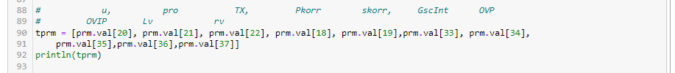

In the utfile (produced when “kal=0) we find the simulation results. This a quite substantial file, which in this example has 39 columns. (The number of columns may differ in the different versions. Some of the columns have also been used for debugging and diagnosing the model) You have to check the statement writing to the “simresult” data frame in the main module (DDD\*…). In the current version (July 2024) of DDDv2 the columns are:

1: "Yr", year

2: "Mnt", month

3: "Day", day

4: "Hr", hour

5: "Min", minute

6: "Precip", precipitation [mm]

7: "Temp", temperature [°C]

8: "Qobs", observed runoff [m³/s]

9: "Qsim", simulated total runoff [m³/s]

10: "Q\_P", simulated runoff P-area [m³/s]

11: "Q\_IP", simulated runoff IP-area [m³/s]

12: "Q\_Bogs", simulated runoff wetlands [m³/s]

13: "SCA\_P", Snow covered area P-area[fraction]

14: "SWE\_P", Snow water eqauivalent P-area [mm]

15: "SS+\_P", Storage subsurface, P-area [mm], inkl overland flow

16: "SS+\_IP", Storage subsurface, IP-area [mm], inkl overland flow

17: "SSDef\_P", Subsurface deficit P- area [mm]

18: "SSDef\_IP", Subsurface deficit IP-area [mm]

19: "SM\_P", soilwater (unsaturated zone) P-area [mm]

20: "SM\_IP", soilwater (unsaturated zone) IP-area [mm]

21: "EA\_P", actual evapotranspiration P-area [mm]

22: "EA\_IP", actual evapotranspiration IP-area [mm]

23: "Qmm", total runoff in [mm]

24: "SM\_Bog", soilwater (unsaturated zone) wetlands [mm]

25: "EA\_Bog", evapotranspiration wetlands [mm]

26: "qmm\_state", diagnostic variable for debugging

27: "Boglyrs", Subsurface storage wetlands [mm]

28: "SCA\_IP", Snow covered area IP-area [fraction]

29: "SWE\_IP2", Snow water equivalent IP-area [mm]

30: "WCS\_P", liquid water in snowpack P-area [mm]

31: "WCS\_IP", liquid water in snowpack IP-area [mm]

32: "SS\_P", storage subsurface excluding overland flow P-area [mm]

33: "SS\_IP", storage subsurface excluding overland flow IP-area [mm]

34: "Q\_OF", runoff as overland flow [m³/s]

35: “outglac”, glacial melt [mm]

36: “r\_sm\_outglac”, rain, snowmelt and glacial melt from glaciated area [mm]

37: “gisoil”, diagnostic variable for debugging

38: ”misoil”, diagnostic variable for debugging

39: ”snittT[1]”, diagnostic variable for debugging

To read and plot from the result file, use, for example an R script.

**6) Calibration**

To calibrate, set «kal=1» in the run script and you choose how many calibration-rounds you want the model to run. If you only calibrate two parameters, the convergence happens quite fast (300 rounds, MaxSteps=300). More parameters demand more calibration rounds.



The number of parameters to calibrate is decided by expand or minimize the range of the parameters.



Only a chosen set of parameters have a range in the above example. If you choose to have no parameter range for a parameter, the parameter will remain a constant.

**References**

Skaugen, T. D. Lawrence and R. Z. Ortega, 2020. A parameter parsimonious approach for catchment scale urban hydrology – Which processes are important?. Journal of Hydrology X, 8, <https://doi.org/10.1016/j.hydroa.2020.100060>

Skaugen T. and C. Onof, 2014. A rainfall runoff model parameterized form GIS and runoff data. *Hydrol. Process*. **28**, 4529-4542,DOI:10.1002/hyp.9968.

Skaugen, T. and Weltzien, I. H., 2016. A model for the spatial distribution of snow water equivalent parameterised from the spatial variability of precipitation, *The Cryosphere*. 10, 1947-1963, doi:10.5194/tc-10\_1947\_2016.

Tsegaw, A.T., Skaugen, T, Alfredsen, K & Muthanna, T.M: [A dynamic river network method for the prediction of floods using a parsimonious rainfall-runoff model](https://iwaponline.com/hr/article/doi/10.2166/nh.2019.003/69546/A-dynamic-river-network-method-for-the-prediction" \t "_blank). Hydrology Research 2019; doi.org/10.2166/nh.2019.003, ISSN 1998-9563 (Published online August 26 2019).